第二章 数列极限

知识点：

含F(Xn,Xn+1):
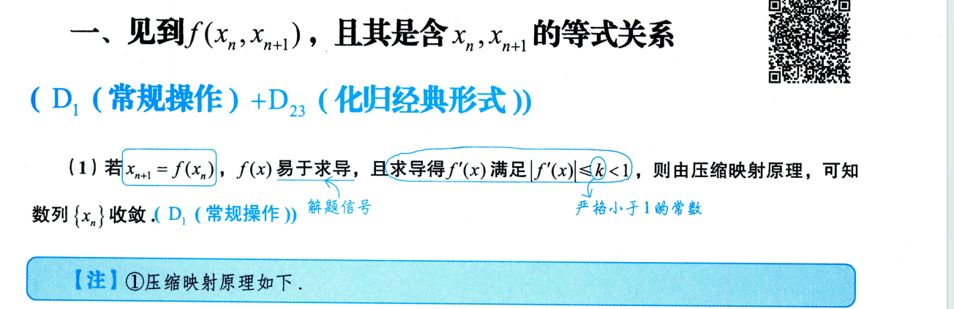
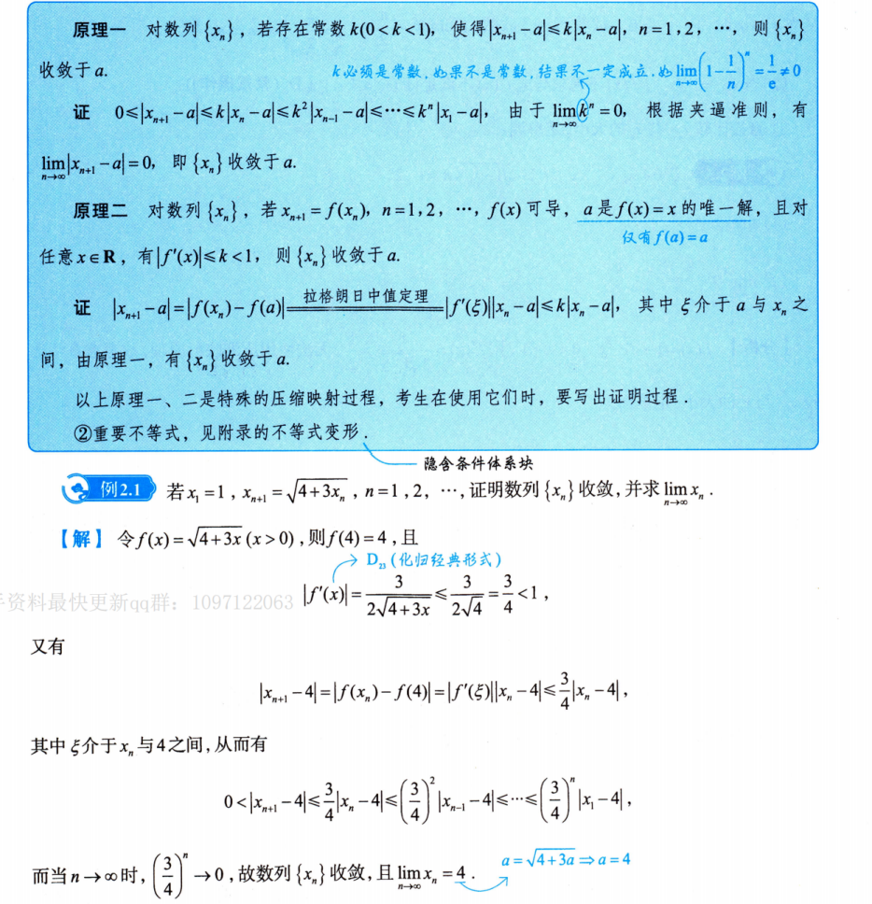
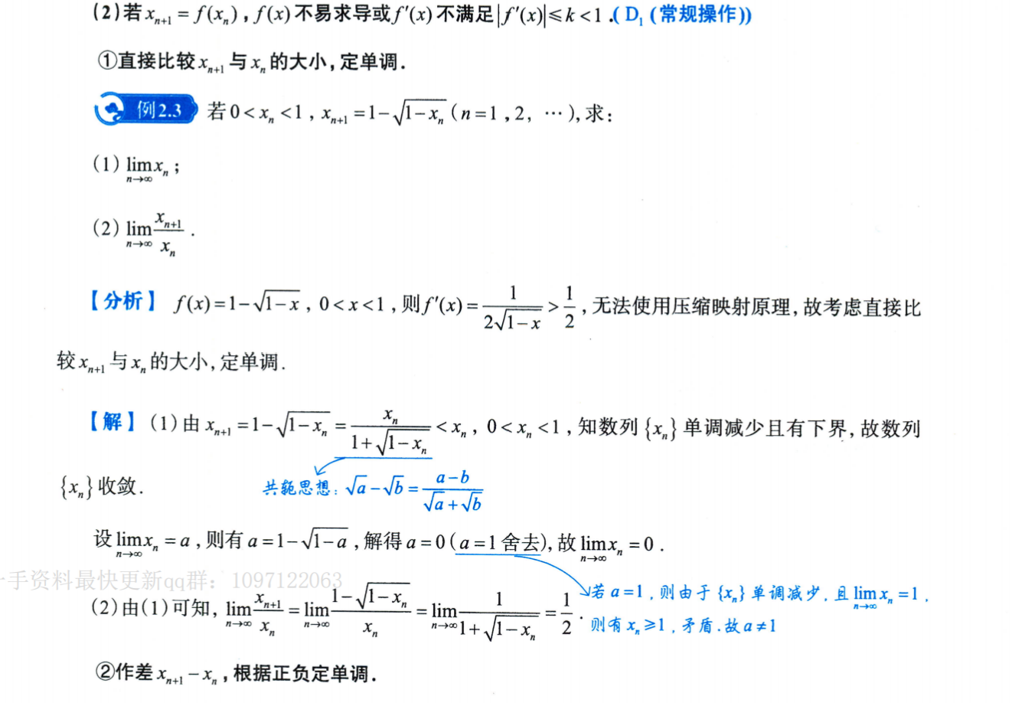
例子2.4：https://chatgpt.com/c/6a7820a7-c750-83e8-a3ae-e9450cc7ea57
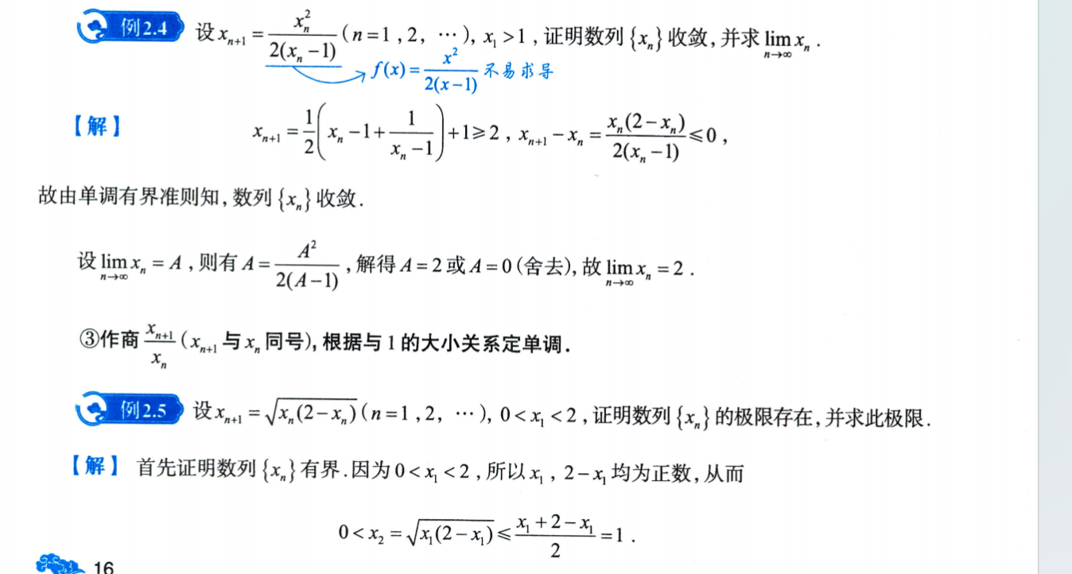
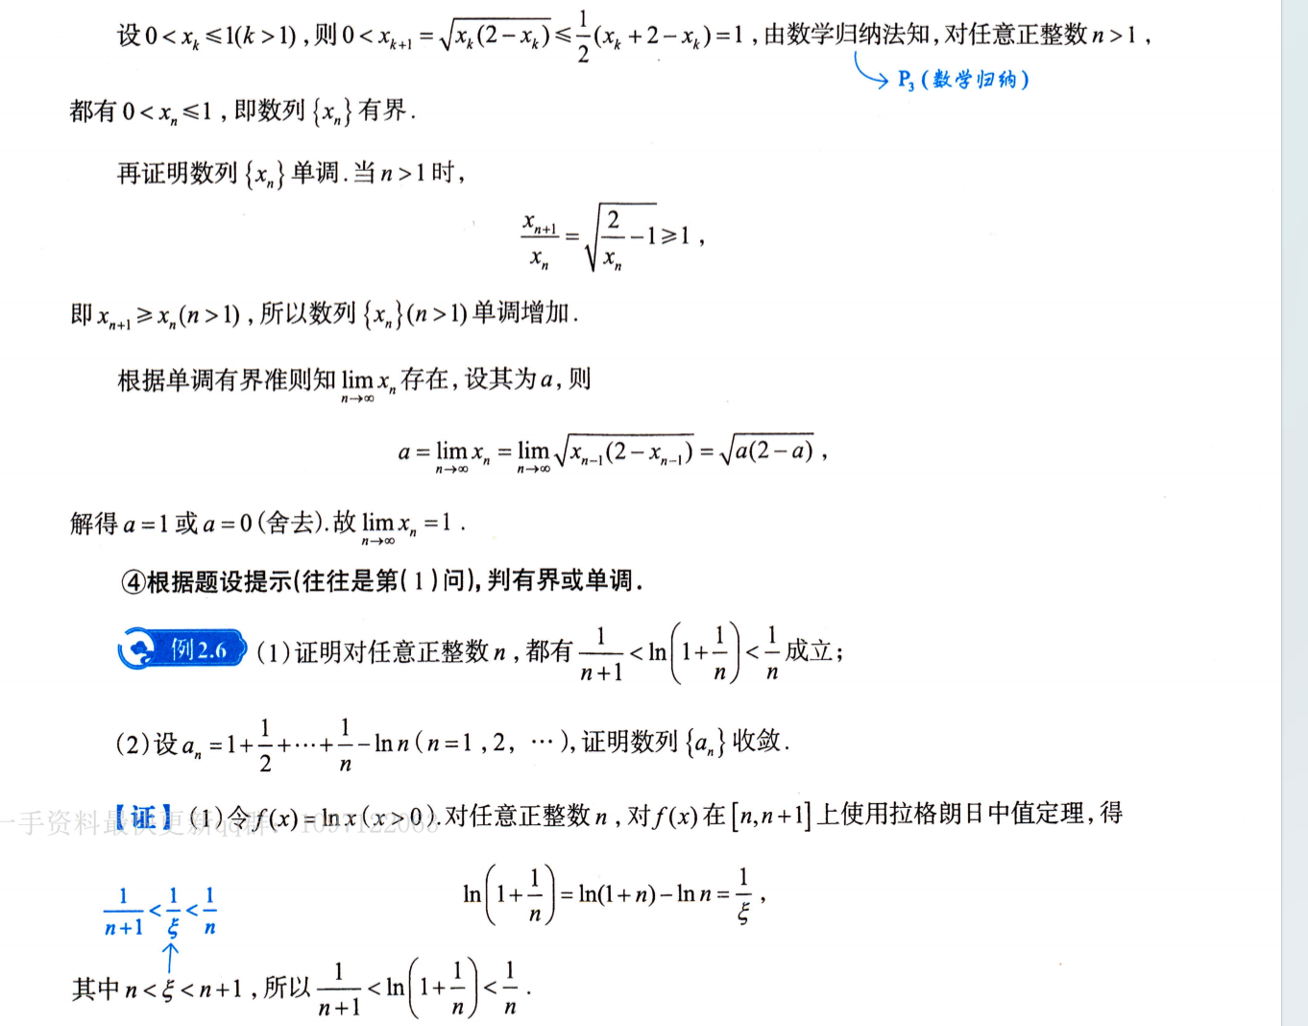
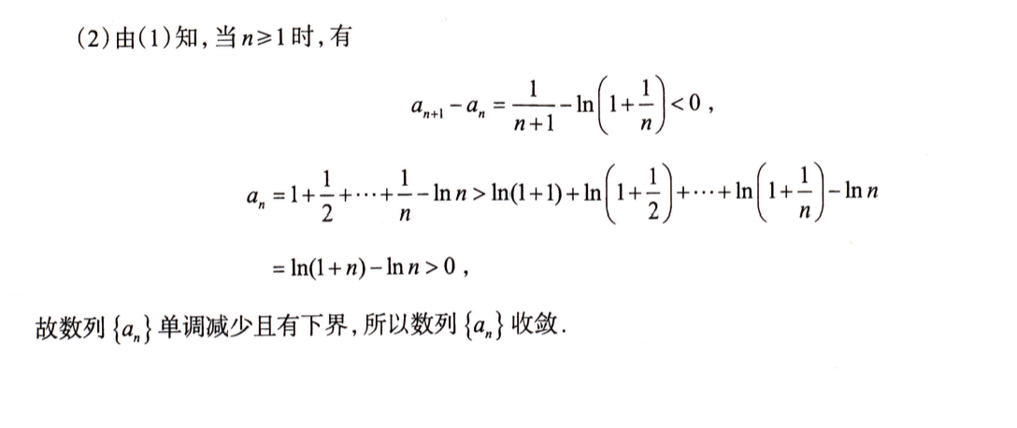

含不等式关系：
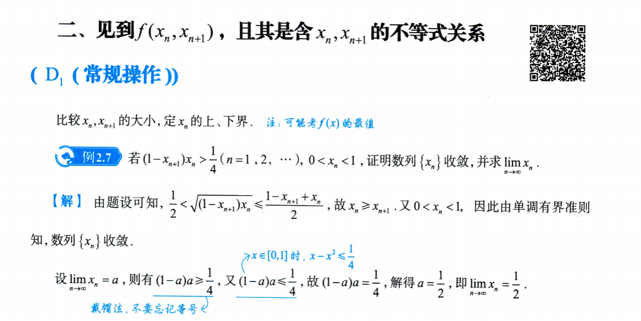

初值对敛散性的影响：
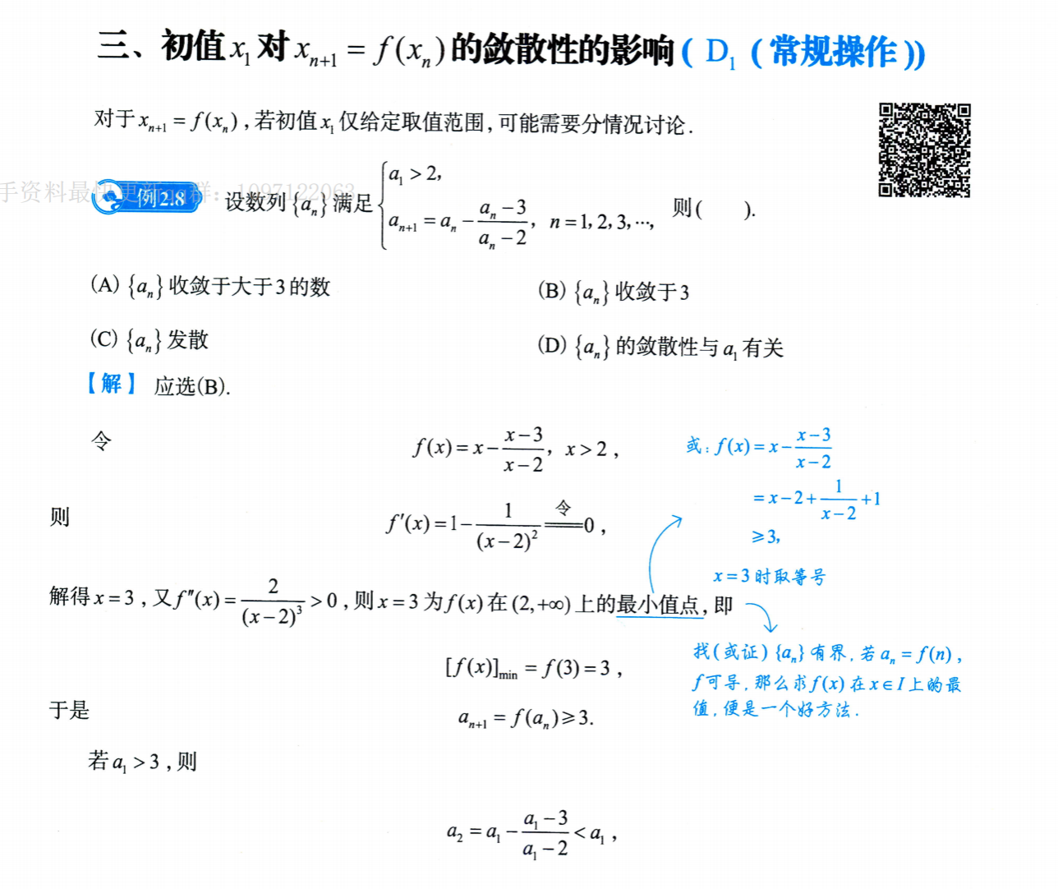
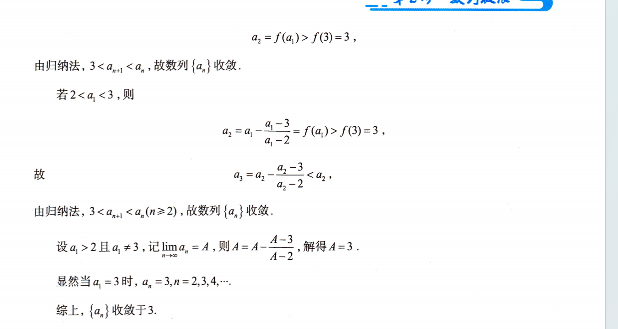
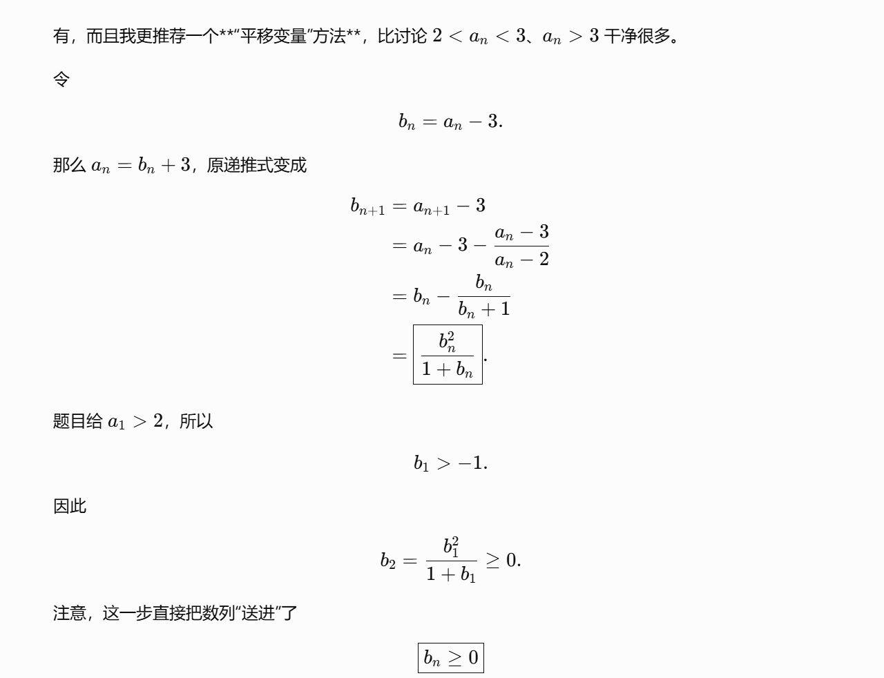
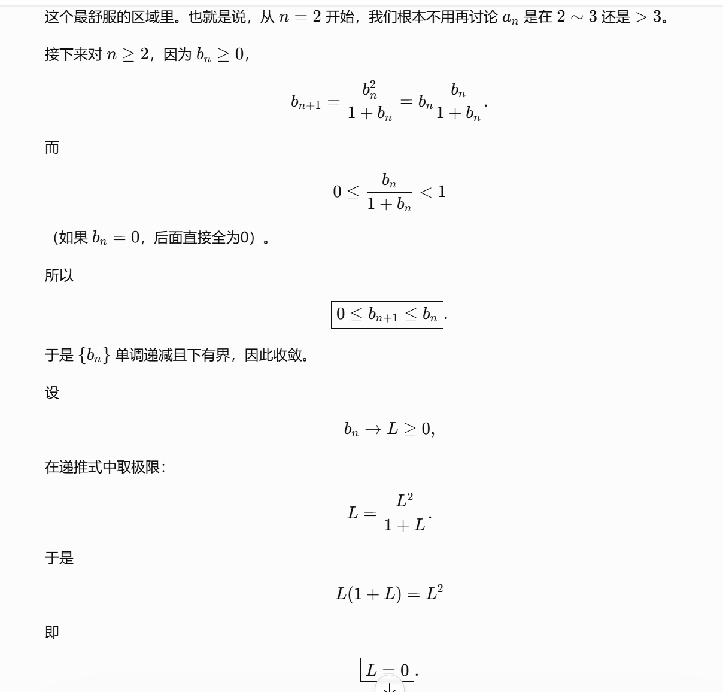
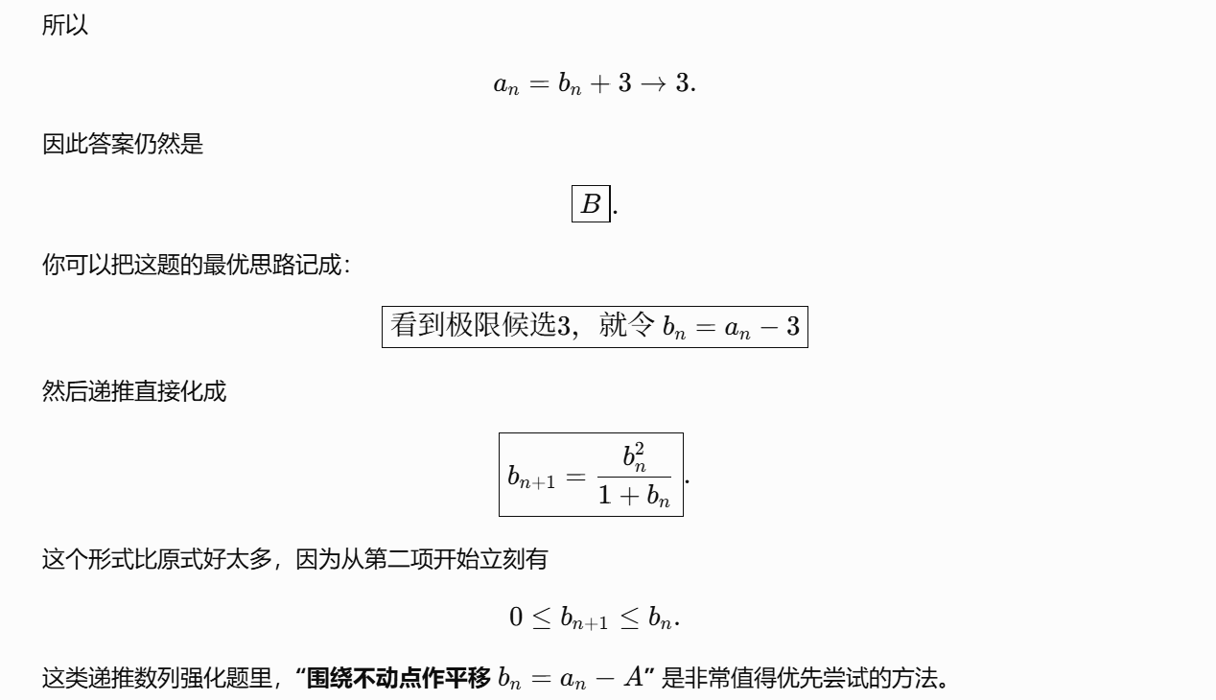
https://chatgpt.com/g/g-p-6a1d505226e08191a7f47eb8e9418ffe-gao-shu-ocr/c/6a7fed81-7590-83ee-9173-6c82e2751010

双通项问题：
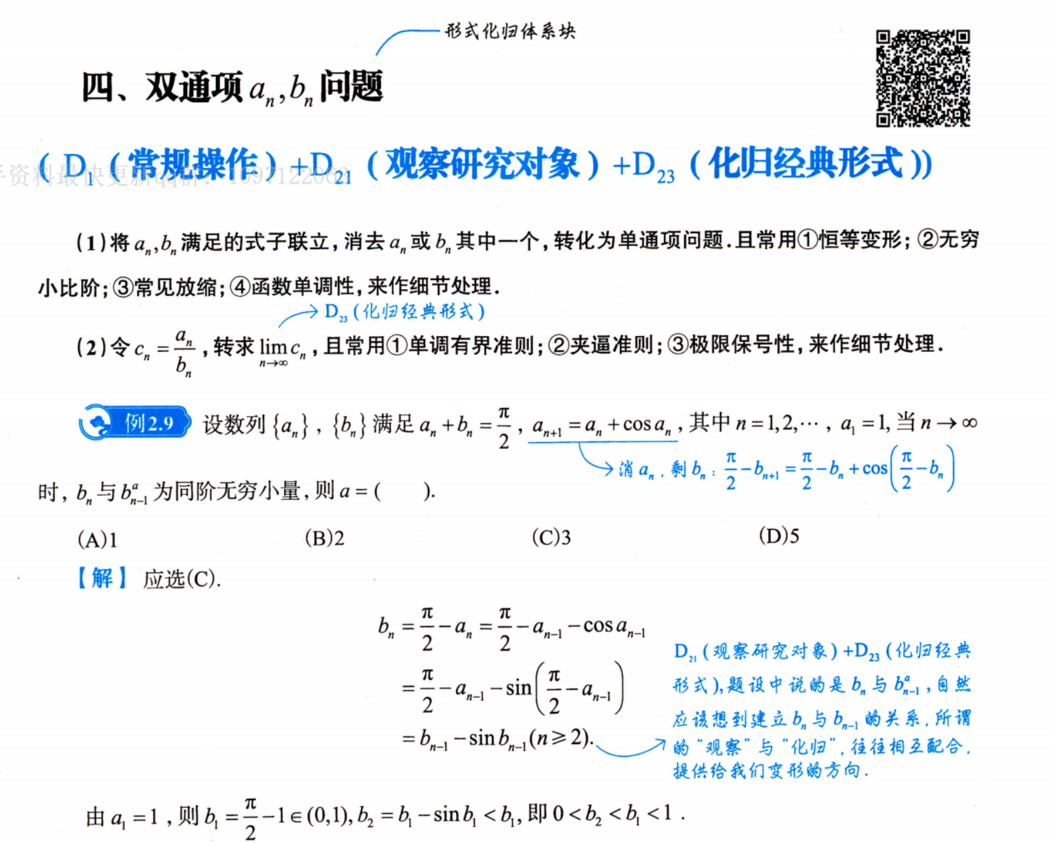
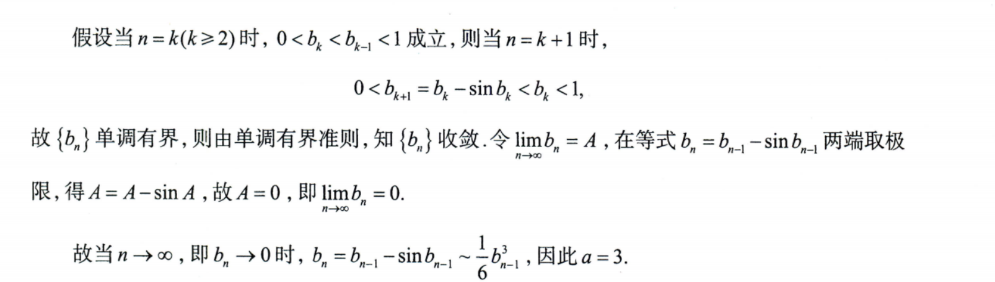
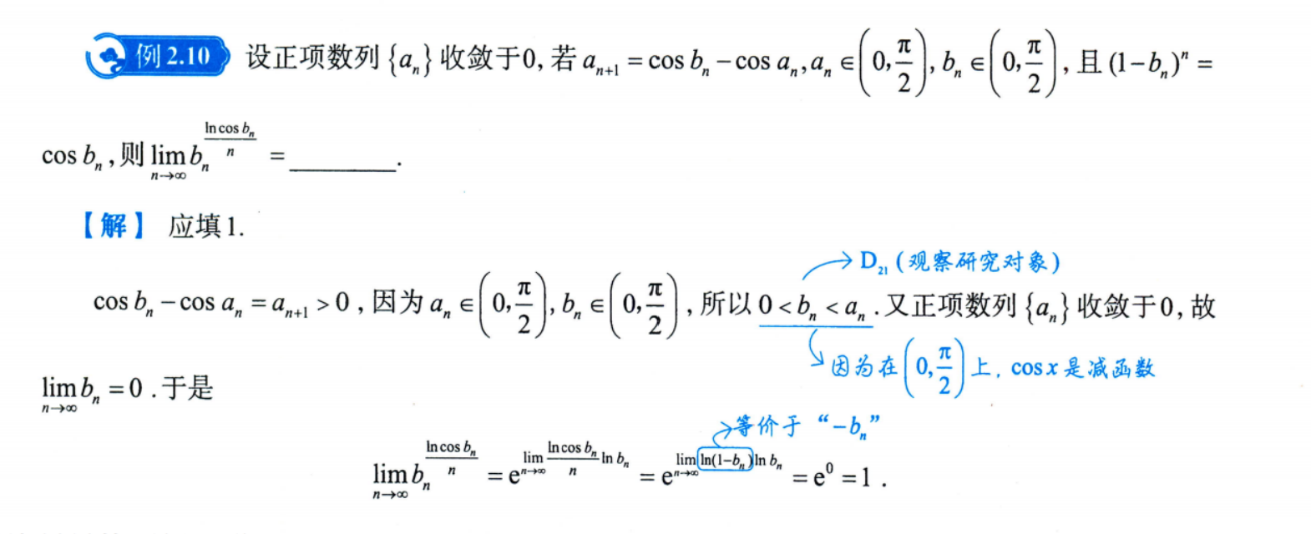

复合函数的极限：
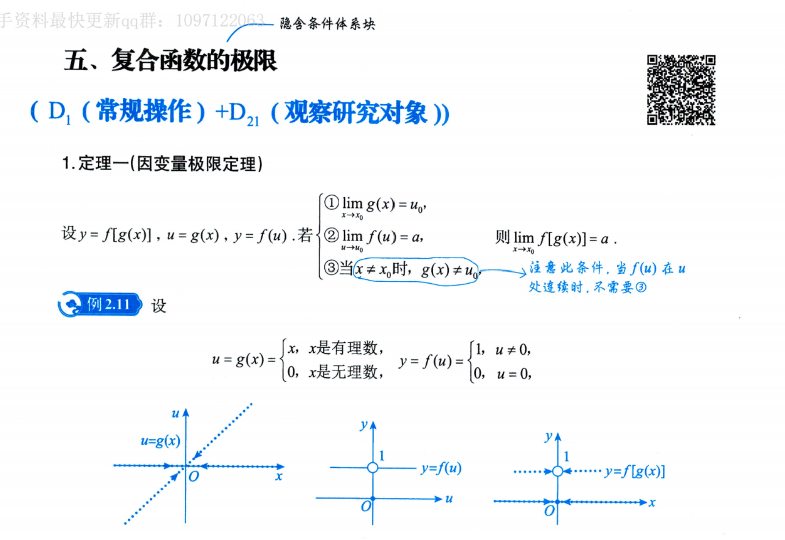
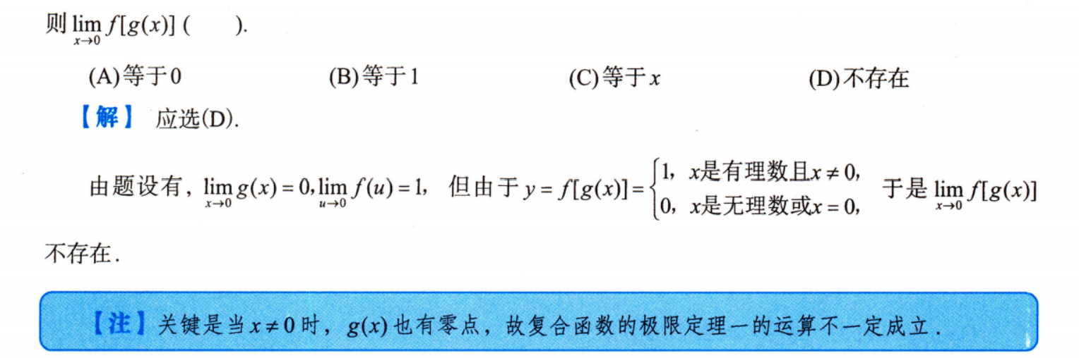
https://chatgpt.com/g/g-p-6a1d505226e08191a7f47eb8e9418ffe-gao-shu-ocr/c/6a7ff706-d554-83e8-9153-e8591fcf565e
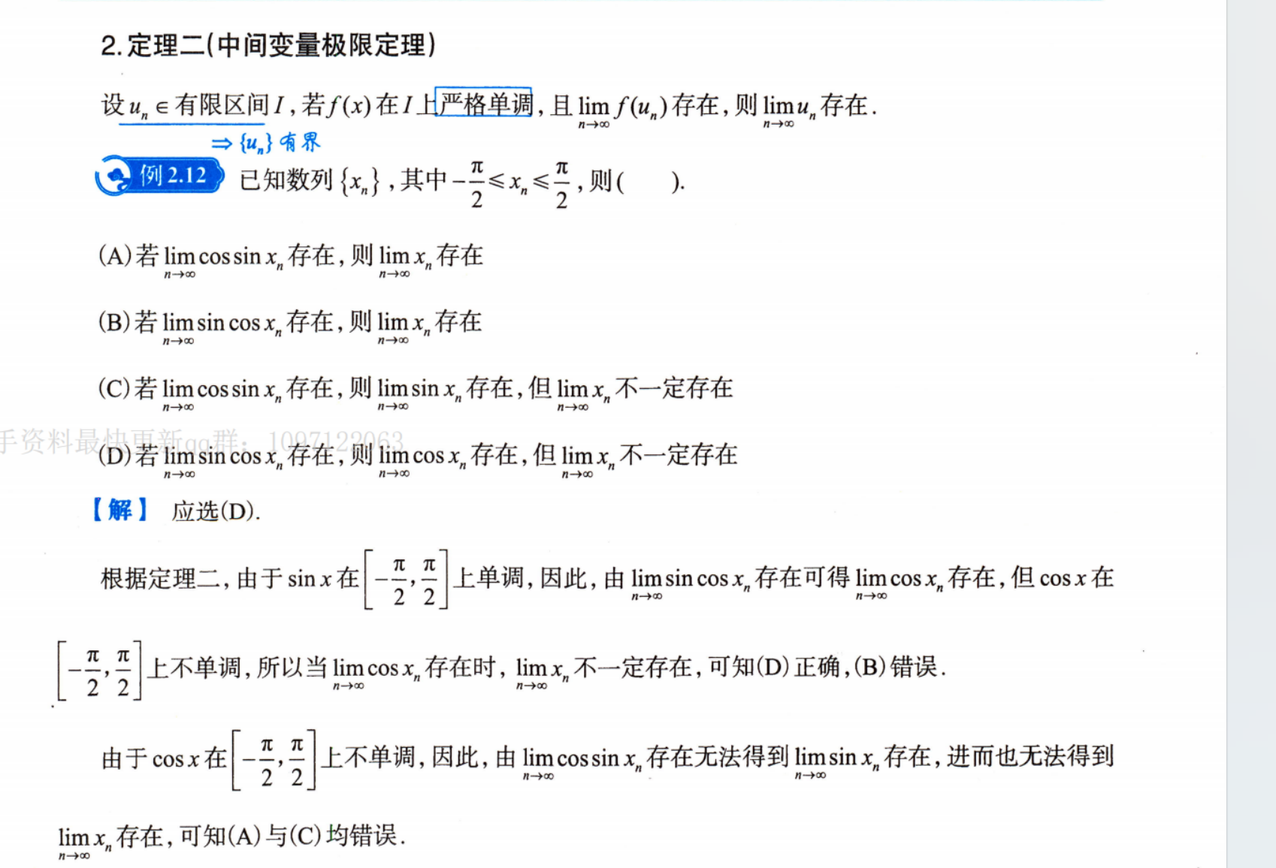
https://chatgpt.com/g/g-p-6a1d505226e08191a7f47eb8e9418ffe-gao-shu-ocr/c/6a7ff9c3-5728-83e8-9d1a-255ce6fe8017
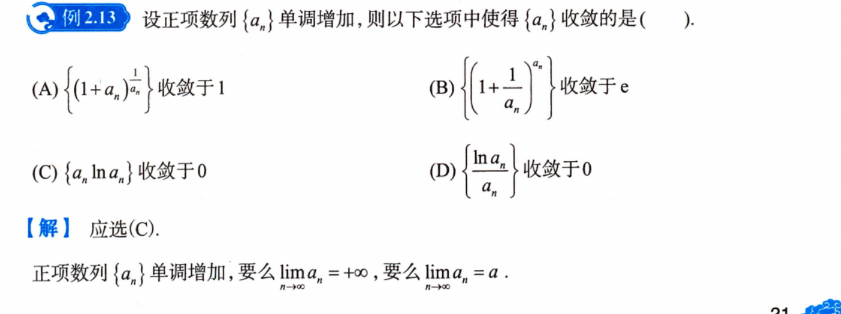
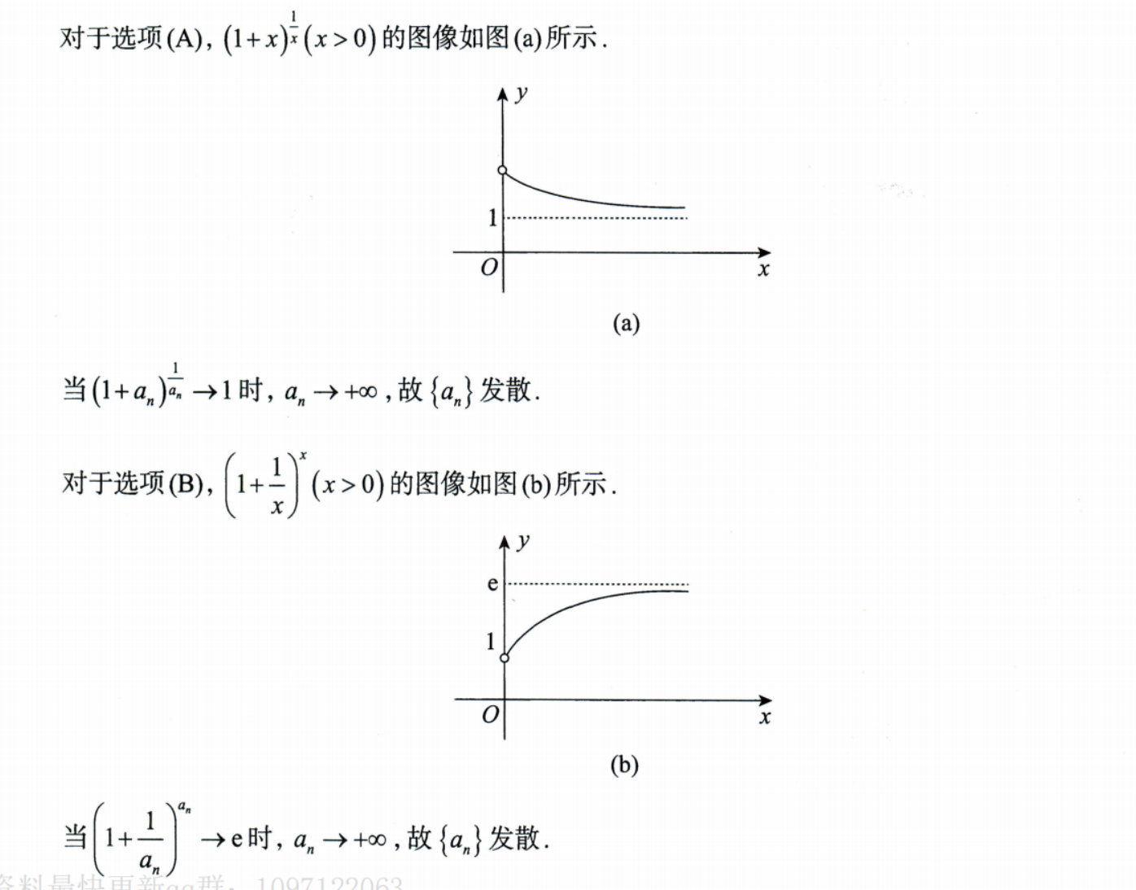
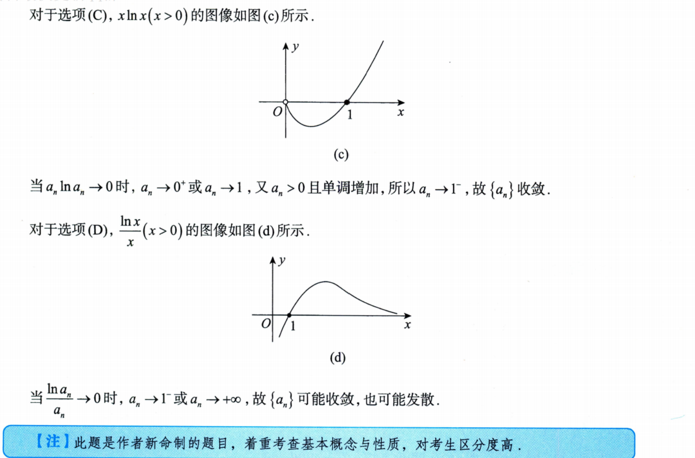

Problems:

单调性问题：
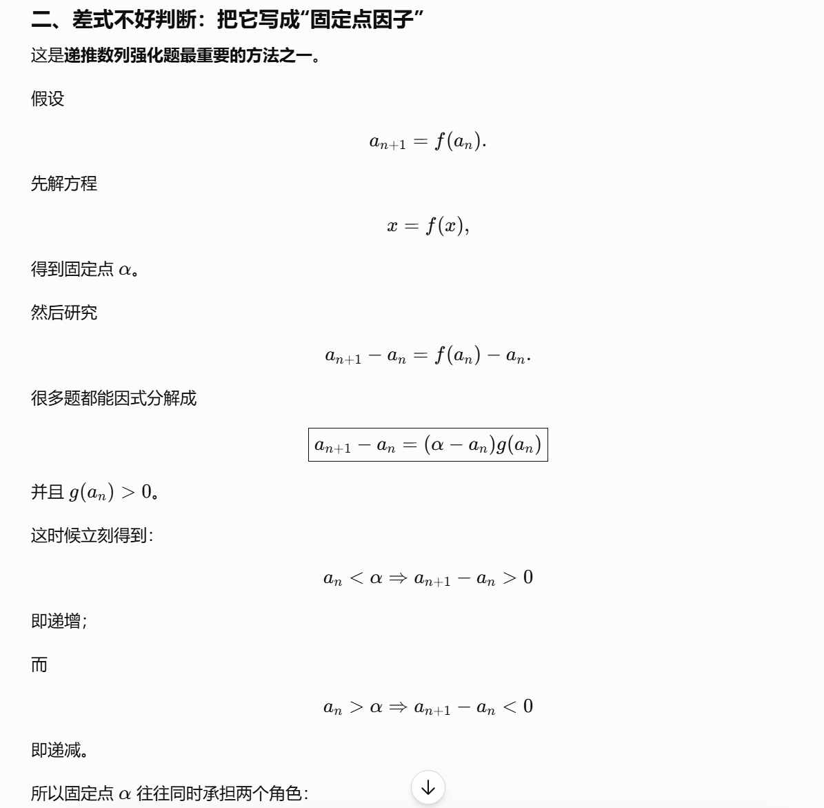

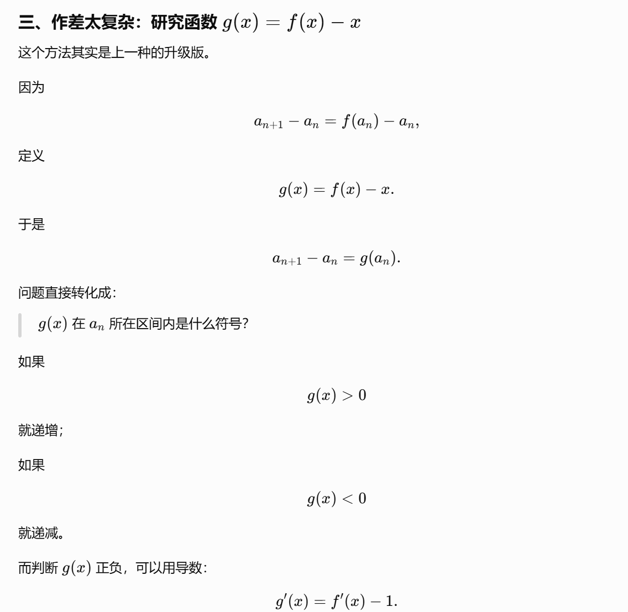
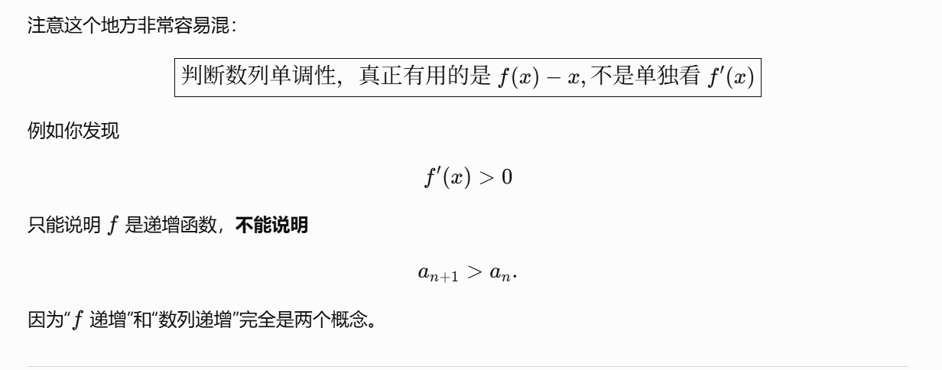
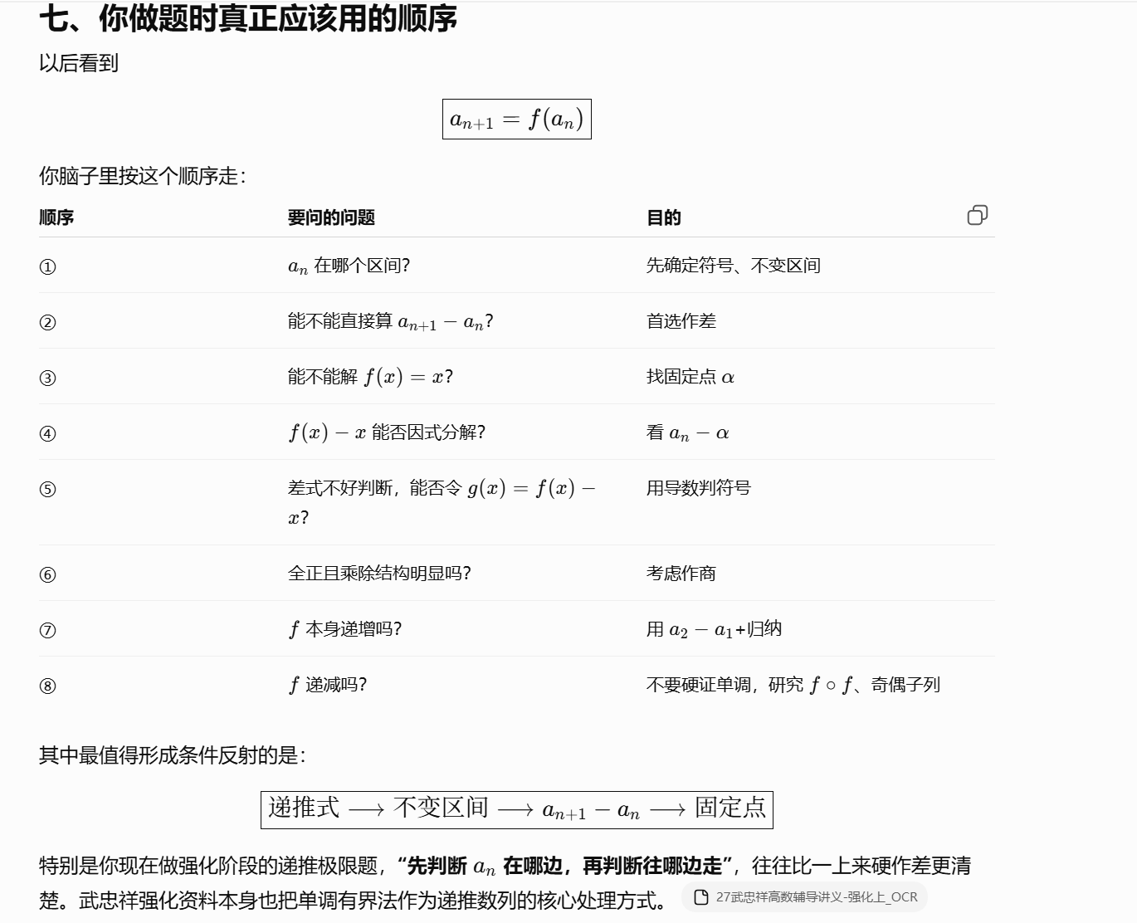
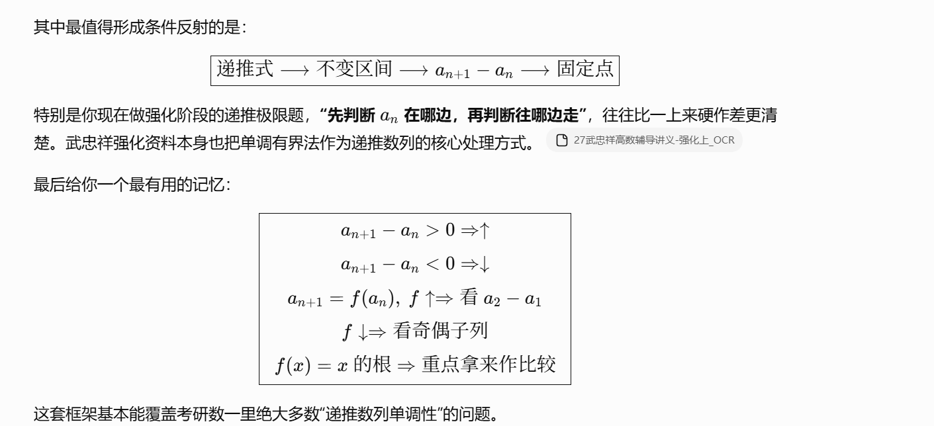
https://chatgpt.com/g/g-p-6a1d505226e08191a7f47eb8e9418ffe-gao-shu-ocr/c/6a818f1e-a588-83e8-921e-ed2d2c895626

区间问题：
https://chatgpt.com/g/g-p-6a1d505226e08191a7f47eb8e9418ffe-gao-shu-ocr/c/6a819c1c-568c-83e8-834e-1e4b507d05eb

URL:
https://chatgpt.com/g/g-p-6a1d505226e08191a7f47eb8e9418ffe-gao-shu-ocr/c/6a781718-af10-83ee-b0de-34fe6911dddf

题：

题1：

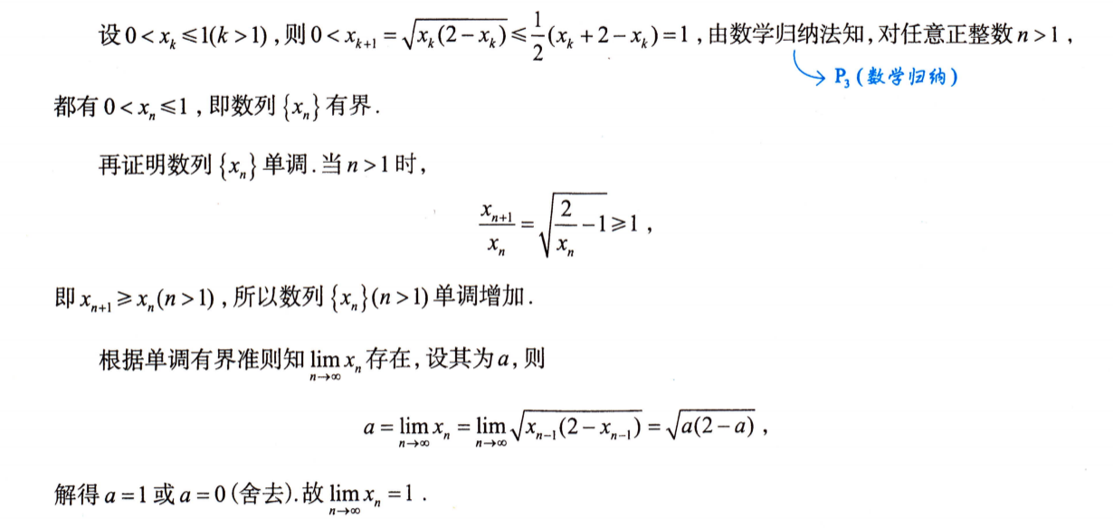
https://chatgpt.com/g/g-p-6a1d505226e08191a7f47eb8e9418ffe-gao-shu-ocr/c/6a7824cb-971c-83e8-a401-b9c7f36bcb30

题2：
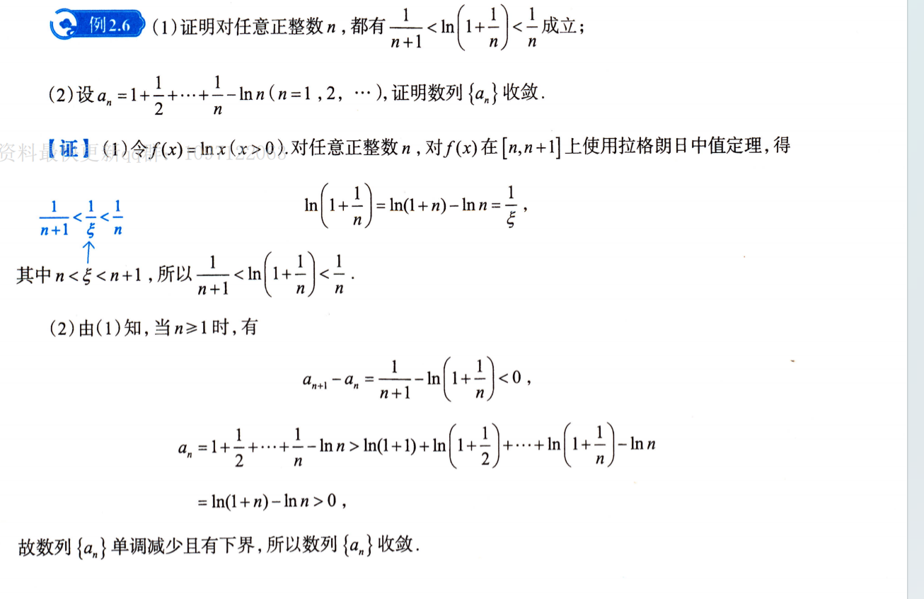

|（注：部分内容可能由 AI 生成）

